Assignment: Programming Strategies

Test/Sample Runs

- You Must exactly generate the following test/sample runs.
- Test runs must be completed in the given order.
- You must use the input values provided.

Test 1: Entering Invalid option as 0, then option 5 to view all Children, and exit

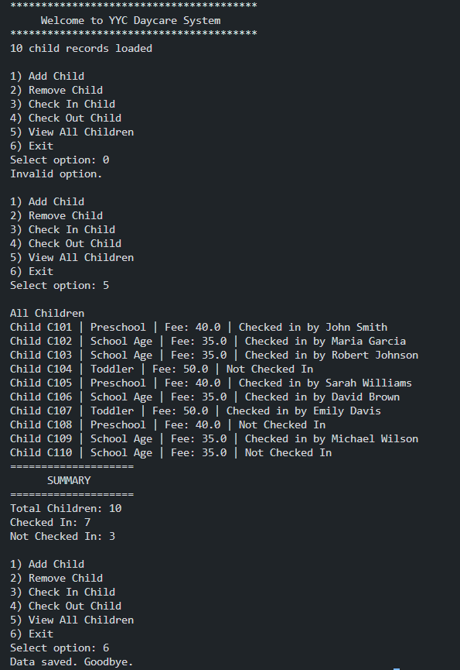

Test 2: Adding a Child which exists and removing a child which does not exist
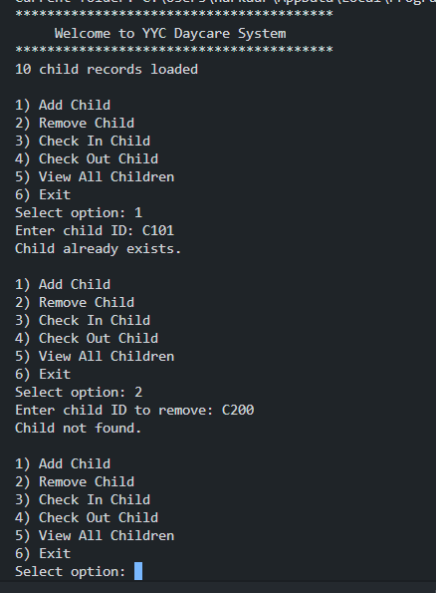

Test 3: Removing a child with invalid child Id number

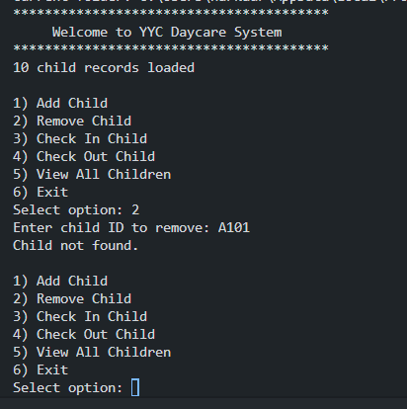

Test 4: Adding a child with invalid Age group or invalid fee (fee <= 0)

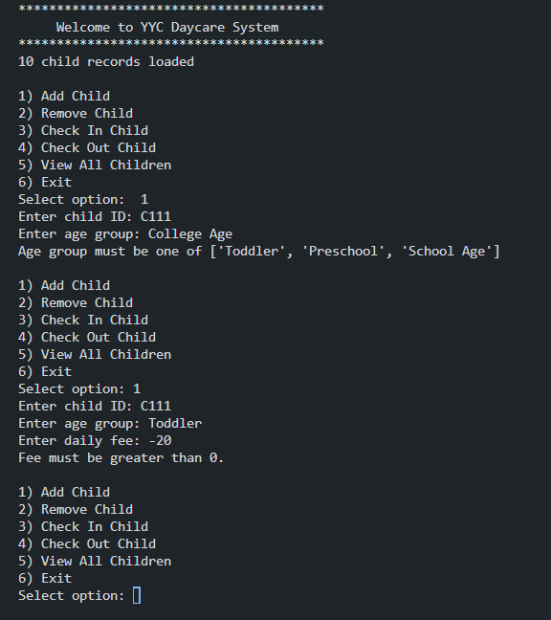

Test 5: Adding a child with valid values then option 5

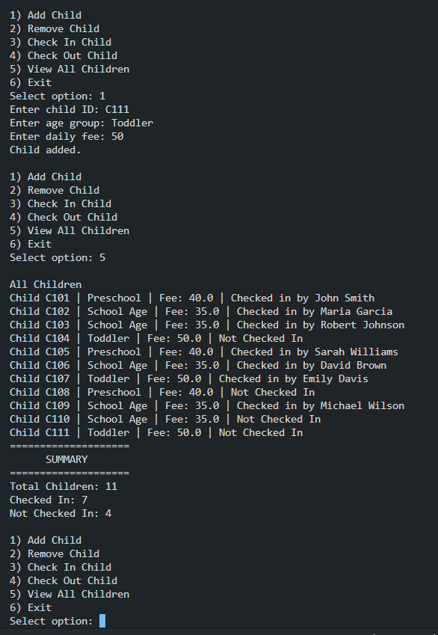

Test 6: Removing a child then option 5

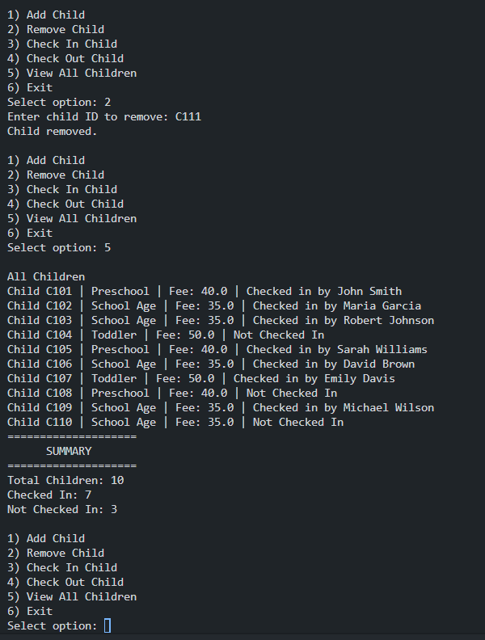

Test 7: Checking in a child with invalid child ID and invalid data then option 5

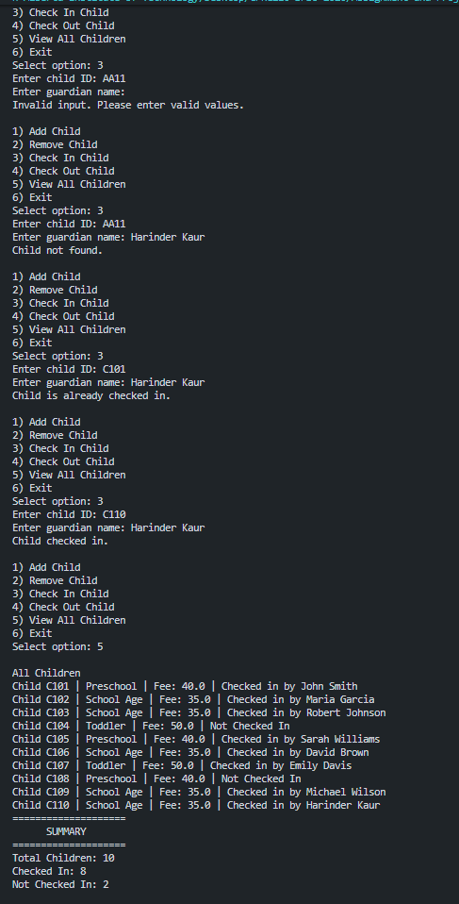

Test 7: Checking out a child with invalid child ID and invalid data then option 5

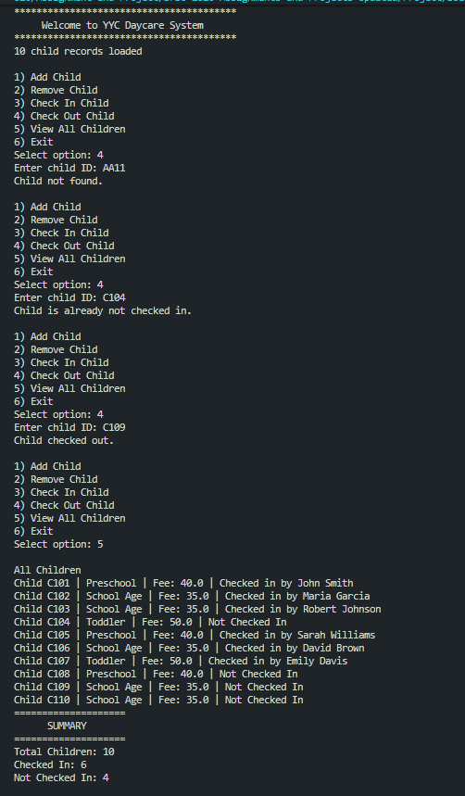

Test 8: Exit the program and save the room data in bookings.csv file

